

**A Message from the Headteacher**

Welcome to our Transition Newsletter that has been specially created to help you have the best start possible at Stafford Manor High School! We are all really excited for you to start with us in September. There is a dedicated area “Admissions” page on our website which contains all the information you need. I hope you will have the chance to look at the ‘Who’s Who’ at Stafford Manor High School, which is a booklet which introduces some key staff.

We value reading at Stafford Manor High School and there is a reading challenge you can complete over the summer of Year 6, with prizes to be given away for the best reading journals completed in September of Year 7. There is also a work booklet to complete, to keep you thinking and learning over the summer. The best workbooks, will also receive prizes in September.

I hope you enjoy the Newsletter and please do not hesitate to get in touch with us at school if you have any more questions. Take care, have a great summer and we will see you soon.

Mr Adams

**First Day Arrangements**

On your first day, you will meet at the main school reception and staff members will be waiting on the veranda to greet you. The first day of the Autumn Term for Year 7 students is Wednesday 4 September and you should arrive at 8.40am.

*A map of the school and example timetable is also provided for you to get a little more familiar with things!*

**Times of the Day**

**Breakfast Club** (Not compulsory – but free for all!)

8.45 – 9.15 Tutor time

9.15 – 10.15 Lesson 1

10.15 – 11.15 Lesson 2

**11.15 – 11.30 Break time**

11.30 – 12.30 Lesson 3

12.30 – 1.30 Lesson 4

**1.30 – 2.15 Lunchtime** (See the sample menu on page 4!)

2.15 – 3.15 Lesson 5

3.15 – 4.15 Extra Curricular Activities (See later for the activities available)

**What should I bring on my first day?**

* Obviously, remember to wear your new uniform!
* Super 7 (This is explained later in the Newsletter)
* A break time snack and water bottle
* A packed lunch if you are not having a hot meal
* Make sure your Parent Pay account has been topped up if necessary
* You will **not** need to bring your PE kit on the first day!

June 2025

**Transition Newsletter**

These are the teacher’s initials – here JFR relates to Mr Freeman (Head of Faculty for Science). Your timetable will come with a list of the names of your teachers and their initials so you can work it out!

This is the room number where the lesson takes place. If it starts with a ‘J’ then the lesson is in Johnson building. If it is an ‘A’ then it is in Anson building. Signs in each building will then guide you to the room number. It is not too difficult!

Science

JFR A20

This is the name of the subject – in this case it is Science.

Most subjects in the timetable above are self-explanatory.

Others less obvious are: Performing Arts (Drama and Music), Digital Communication (ICT) and SEL or Social and Emotional Learning (Personal, Social and Health Education).

You can go home after lesson 5 (3pm) but the space in session 6 may be where you add an extracurricular activity!

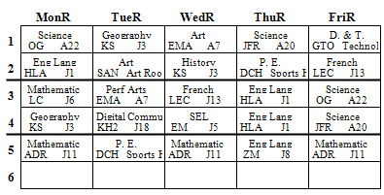

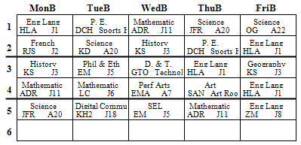

This dark line indicates it is lunch time after lesson 4 (1.20pm).

This dark line indicates it is break time after lesson 2 (11.00pm).

We have **‘Red’** and **‘Blue’** weeks at SMHS. The first week in September is a **‘Red’** week and then the weeks alternate through the year. Your tutor will always remind you whether it is a **‘Red’** or **‘Blue’** week!

We have five lessons a day. Each lesson is one hour long. Remember tutor time starts the day at 8.45 (but is not shown here). The times of each lesson can be found in the Newsletter.

**How do I read my timetable?**

You will be given a timetable on your first day at school. This will tell you exactly where you need to be for each lesson during the day. Your timetable also helps you plan what you need to take to school the following day – it is always a good idea to pack your bag the night before! The example below shows you how a timetable looks and contains some helpful notes to explain how you read your timetable. Please note - this is not your actual timetable!

**School Uniform**

In addition to this you will also need:

**Black trousers** – these must be standard school trousers, **no leggings or jeans**

**Black skirt** – must be knee length and worn with black opaque tights

**Footwear** – sensible all black footwear, preferably shoes, with no coloured logos, markings or laces

**Socks/tights** – black

**Shirt** – white with collar. Shirt must be tucked in.

**Plain Black V-Neck Jumper** – May be worn under the blazer but must not come below the length of the blazer and cannot be worn as an alternative to the blazer.

**PE Kit**

**Compulsory items for PE:**

**PE Top** – black with red sports top with SMHS logo

**Indoor shorts** – plain black

**Outdoor tracksuit bottoms or sports leggings** - plain black

**Suitable Sports Trainers** – with a non-marking sole

Further items for PE include:

**PE Hoodie** – these are available through Crested Schoolwear and particularly useful through the winter.

**Football boots and socks –** not essential, but these may be useful for football and rugby

**Gum shield** – not essential, but available for £1.80 from the PE office if children enjoy rugby

[](https://www.bing.com/images/search?view=detailV2&ccid=8MMyqXZB&id=97D16266CD827F9752F68CEAE561EDF0F84D0D5C&thid=OIP.8MMyqXZBl1-Bdgx192BvqgHaHa&mediaurl=http%3a%2f%2fwww.cathedralprimaryschool.com%2freception%2ffiles%2f2015%2f09%2fP.E.png&exph=1252&expw=1252&q=PE+Kit+Clip+Art&simid=608011032141694046&ck=F66C71DF841E955DC5134BC8176222A0&selectedIndex=3&adlt=strict)

Good punctuality and attendance is a valuable habit.

**8:30am** School gates are open

**8:40am** All students should be on school site

**8:43am** All students should be waiting at their dedicated line up location or ready for tutor time or assembly

**Attendance and Behaviour**

[](https://www.bing.com/images/search?view=detailV2&ccid=nrLVpHYN&id=84BE1803889123042CBAA614F663172201866CC2&thid=OIP.nrLVpHYNqXqvUc0qCYtEPAHaE0&mediaurl=https%3a%2f%2fwww.corbytechnicalschool.org%2f_files%2fimages%2f9EB2D5A4760DA97AAF51CD2A098B443C.png&exph=474&expw=728&q=Attendance&simid=608029831148077888&ck=8D7E661F02BFD60E5D22488FA4DC5328&selectedIndex=32&adlt=strict)

We always ask students to aim for 100% attendance, the absolute minimum expectation is to be in school for 96% of the time. If your child is ill and cannot attend school one day, then please contact the Attendance Co-ordinator on the school telephone number before 8.45am.

The staff at SMHS will always be ready to guide and support students and parents if there are difficulties with punctuality and attendance. There is more guidance about the school term dates and term time holidays on the school website.

Our school policies for attendance, behaviour and other relevant aspects of school life can be found in the ‘parents’ tab on our [school website](https://www.staffordmanorhighschool.com/).

[](https://www.bing.com/images/search?view=detailV2&ccid=Yaoj5Vnq&id=7E97BEE77B117DD27B956A957770E51AB3D96554&thid=OIP.Yaoj5VnqOAqIB9mZJgI32AHaGU&mediaurl=https%3a%2f%2fmedia.istockphoto.com%2fvectors%2fback-to-school-vector-id479399111%3fk%3d6%26m%3d479399111%26s%3d612x612%26w%3d0%26h%3dVoz8KnNN1JmrjpsexpWVqGQPTXP-Q0JvLdTNGUGA8r4%3d&exph=522&expw=612&q=School+Uniforms+clipart&simid=608003262495592108&ck=E2FBB45ACF9AF26A5D4606E88A74FE05&selectedIndex=124&adlt=strict)

Uniform can be purchased from:

***Crested Schoolwear, Gaolgate Street, Stafford*** or online

<https://www.crestedschoolwear.co.uk/>

**Blazer** – black with SMHS logo

**PE Top –** black and red sports top with SMHS logo

**School Tie** – black/red stripes

**What subjects will I study at SMHS?**

English History French Performing Arts

Maths Geography Design Technology Computing

Science PE Art and Design Philosophy and Ethics

Social and Emotional Learning

You will be provided with a Transition Workbook with lots of activities to complete over the summer holiday for each of the subjects you will study. This provides a great introduction to each subject and will help prepare you for September. More information about each subject can also be found in the ‘Learning Resources’ page of our website.



**Super 7**

It is very important that you come to school equipped with some

basic essentials. They are as follows:

**School bag Blue or Black Pen and a red pen**

**Pencil Eraser**

**Ruler Reading Book**

**Any homework that is due to be handed in that day**

You may also bring other items including coloured pens or pencil crayons if you wish.

**Mobile Phones**

We do allow our students to bring mobile phones to school but they must not be used during the school day and they are the student’s responsibility to look after. Please be aware that we cannot be responsible for any damage, loss or theft of mobile phones or other technology brought to school. Mobile phones **must** be out of site whilst on site. Students seen using a mobile phone during the school day, will have to hand it in until the end of the day and can then have it back.

**Our simple reminder for mobile phones is – If we see it, you will lose it!**

See it, hear it, Lose it

**Parent Pay & Free School Meals**

We are a totally cashless school and we use a system called Parent Pay.

You will receive a letter in the post with a username and password.

**Please keep this safe!**

To use the canteen, students will have their thumbprint taken on the first day. If you decide to opt out of the thumbprint option then your child will receive a code to use to purchase their food.

If your child is eligible for free school meals, their account will be credited daily so they can purchase food from the canteen. If you are currently not registered for free school meals, and feel you may be entitled to apply then all the information can be found at [www.staffordshire.gov.uk/freeschoolmeals](http://www.staffordshire.gov.uk/freeschoolmeals).

**What extra-curricular activities could I join?**

Some examples of extra-curricular activities we do at SMHS are:

Student Leadership French Club Science Club DT Club

Football Club Netball Club Keyboard Club Art Club

Drama Club IT Club Gardening Club Debating Club

We always encourage our pupils to get involved and try something new!



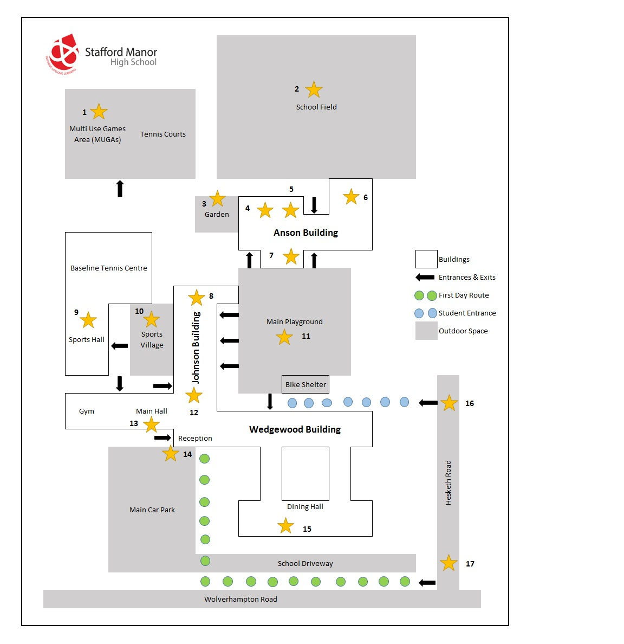

**Contact details**

**Stafford Manor High School**

Wolverhampton Road

Stafford

ST17 9DJ

Telephone: 01785 258383

Email (general enquiries): [office@smhs.staffs.sch.uk](mailto:office@smhs.staffs.sch.uk)

Email (help with work pack): [ks3support@smhs.staffs.sch.uk](mailto:ks3support@smhs.staffs.sch.uk)

Lots of information can be found on our website <https://www.staffordmanorhighschool.com/>

**Map of the School**