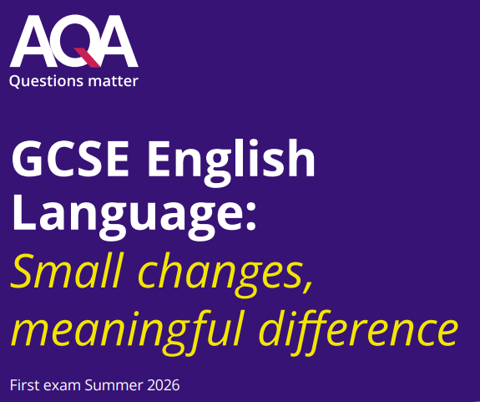

English Language
Exam Style Questions
Miss Parkes

Name:…………………………………………
Class:……………………………………………
English Language PAPER 1
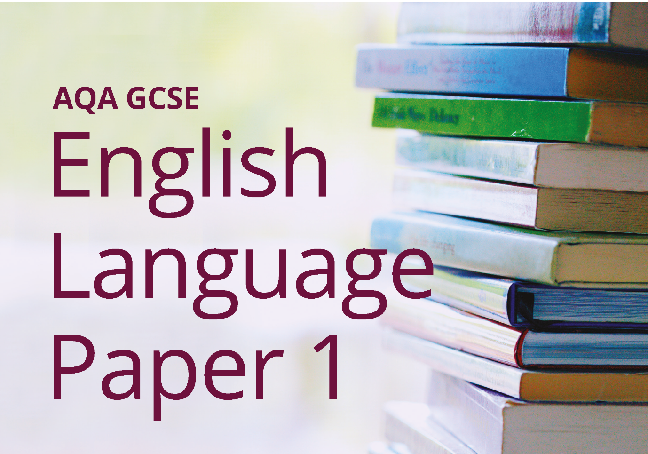

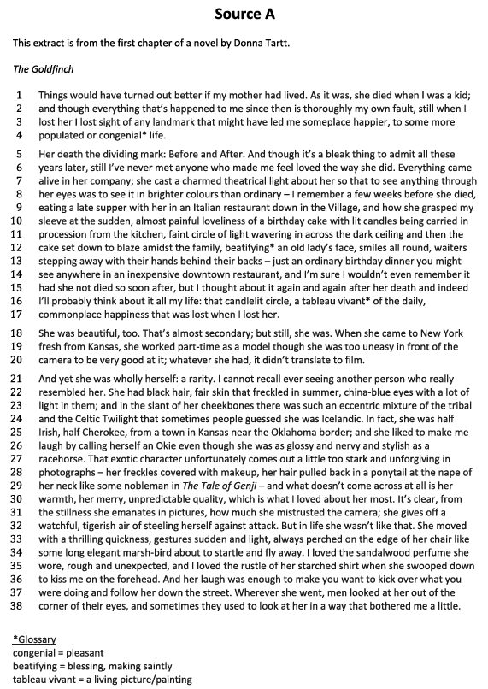
Section A: Reading
Q1. Read again the first part of the Source from lines 1 to 6.
For each of the following statements about the narrator, choose the answer you think is most accurate.
1. Who is the narrator grieving for?
- His father
- His sister
- His mother
- His teacher
2. What does the narrator say about his life after the loss?
- It changed suddenly
- It improved over time
- It stayed exactly the same
- He can't remember anything
3. How does the narrator feel about his mother's love?
- It was ordinary
- It was brief
- It was unlike anything else
- It made him angry
4. What event does the narrator link to the course of his life changing?
- Winning a competition
- Moving house
- Losing his mother
- Starting school

[4 marks]

Q2. Lines 5 to 20 focus on how the narrator remembers his mother.
How does the writer use language to describe the narrator’s relationship with his mother?
You could include the writer’s choice of:
- Words and phrases
- Language features and techniques
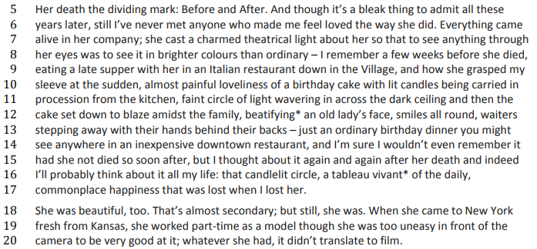
- Sentence forms

[8 marks]

🔍 Q3. Now read the whole of Source A.
How has the writer structured the text to create a sense of loss?
You could write about:
- What the writer focuses your attention on at the beginning
- How and why the writer changes this focus as the Source develops
- Any other structural features that create a sense of loss
[8 marks]
💫 Q4. Focus this part of your answer on the second part of the Source from line 18 to the end.
The description is so vivid that the character of the mother really seems to come to life.
To what extent do you agree with this statement?
In your response, you could:
- Write about your own impressions of the mother
- Evaluate how the writer uses methods to create those impressions
- Support your ideas with references to the text
[20 marks]
Section B: Writing

Q5. Choose one:
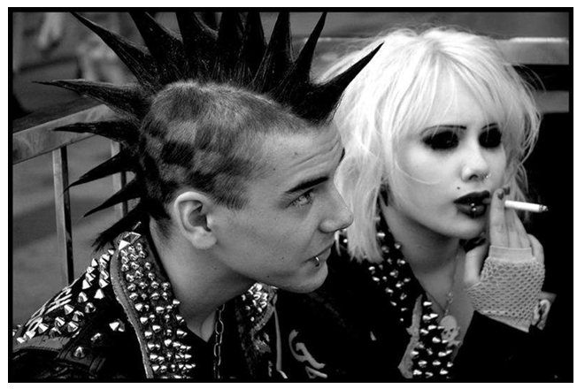
Option A: Description
Write a description of an unusual person, as suggested by this picture.
You can use your imagination—you do not have to describe the picture exactly.

Option B: Narrative Opening
Write the opening of a story with the title The Outsider.
You do not need to write the whole story.

[40 marks: 24 for content and organisation, 16 for technical accuracy]

Writing pages:
________________________________________________________________________________________________________________________________________________________________________________________________________________________________________________________________________________________________________________________________________________________________________________________________________________________________________________________________________________________________________________________________________________________________________________________________________________________________________________________________________________________________________________________________________________________________________________________________________________________________________________________________________________________________________________________________________________________________________________________________________________________________________________________________________________________________________________________________________________________________________________________________________________________________________________________________________________________________________________________________________________________________________________________________________________________________________________________________________________________________________________________________________________________________________________________________________________________________________________________________________________________________________________________________________________________________________________________________________________________________________________________________________________________________________________________________________________________________________________________________________________________________________________________________________________________________________________________________________________________________________________________________________________________________________________________________________________________________________________________________________________________________________________________________________________________________________________________________________________________________________________________________________________________________________________________________________________________________________________________________________________________________________________________________________________________________________________________________________________________________________________________________________________________________________________________________________________________________________________________________________________________________________________________________________________________________________________________________________________________________________________________________________________________________________________________________________________________________________________________________________________________________________________________________________________________________________________________________________________________________
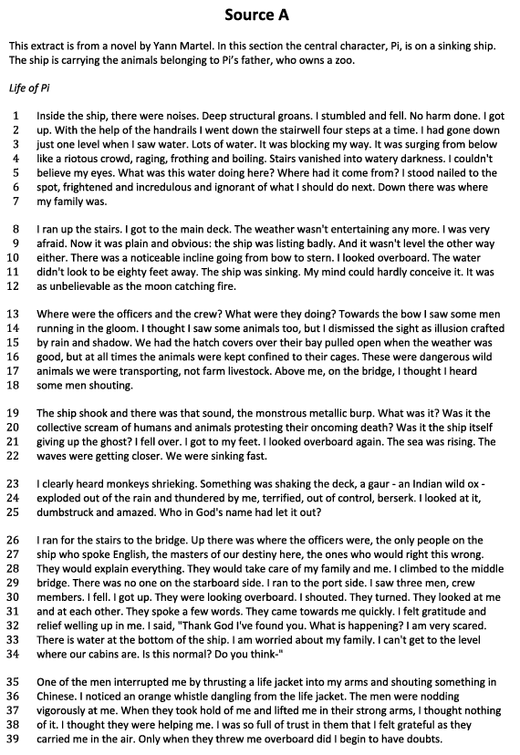

Section A: Reading

Q1. Read again the first part of the Source from lines 1 to 12.
For each of the following statements about the ship, choose the most accurate answer.

1. What is happening to the ship?
- It is preparing to dock
- It is sinking
- It is sailing smoothly
- It is being repaired
2. What does the narrator notice about the water?
- It is calm
- It is churning and rising
- It has dried up
- It is clean and clear
3. What is the narrator doing during this moment?
- Sleeping
- Swimming
- Watching the scene unfold
- Eating
4. What time of day is it in the extract?
- Early morning
- Midday
- Night
- Late afternoon

[4 marks]

Q2. Look in detail at this extract from lines 13 to 25 of the Source.
How does the writer use language here to describe the narrator's fright and confusion?
You could include the writer’s choice of:
- Words and phrases
- Language features and techniques
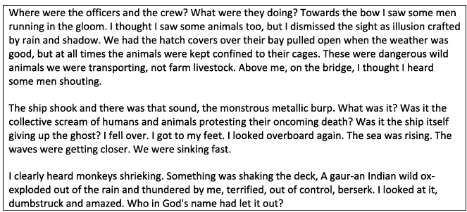
- Sentence forms
[8 marks]
Q3. Now read the whole of Source A.
How has the writer structured the text to create suspense?
You could write about:
- What the writer focuses your attention on at the beginning
- How and why the writer changes this focus as the Source develops
- Any other structural features that create suspense
[8 marks]
Q4. Focus this part of your answer on the second part of the Source from line 19 to the end.
The writer makes the reader feel sympathetic for the narrator.
To what extent do you agree with this statement?
In your response, you could:
- Write about your own impressions of the narrator
- Evaluate how the writer uses methods to create those impressions
- Support your ideas with references to the text
[20 marks]
Section B: Writing

Q5. Choose one:
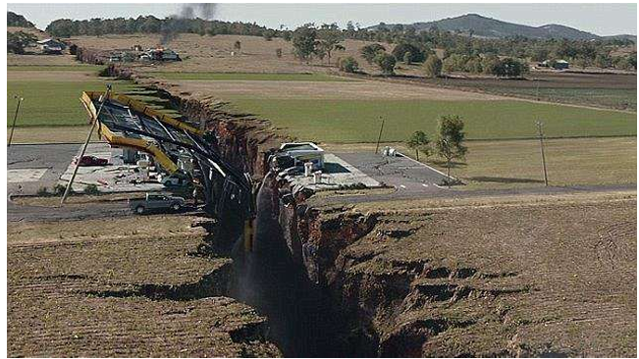
Option A: Description
Write a description of a life-changing event, as suggested by this picture.
You can use your imagination—you do not have to describe the picture exactly

Option B: Narrative Opening
Write the opening of a story in which a dramatic event occurs.
You do not need to write the whole story.

[40 marks: 24 for content and organisation, 16 for technical accuracy]

Writing pages:
________________________________________________________________________________________________________________________________________________________________________________________________________________________________________________________________________________________________________________________________________________________________________________________________________________________________________________________________________________________________________________________________________________________________________________________________________________________________________________________________________________________________________________________________________________________________________________________________________________________________________________________________________________________________________________________________________________________________________________________________________________________________________________________________________________________________________________________________________________________________________________________________________________________________________________________________________________________________________________________________________________________________________________________________________________________________________________________________________________________________________________________________________________________________________________________________________________________________________________________________________________________________________________________________________________________________________________________________________________________________________________________________________________________________________________________________________________________________________________________________________________________________________________________________________________________________________________________________________________________________________________________________________________________________________________________________________________________________________________________________________________________________________________________________________________________________________________________________________________________________________________________________________________________________________________________________________________________________________________________________________________________________________________________________________________________________________________________________________________________________________________________________________________________________________________________________________________________________________________________________________________________________________________________________________________________________________________________________________________________________________________________________________________________________________________________________________________________________________________________________________________________________________________________________________________________________________________________________________________________________
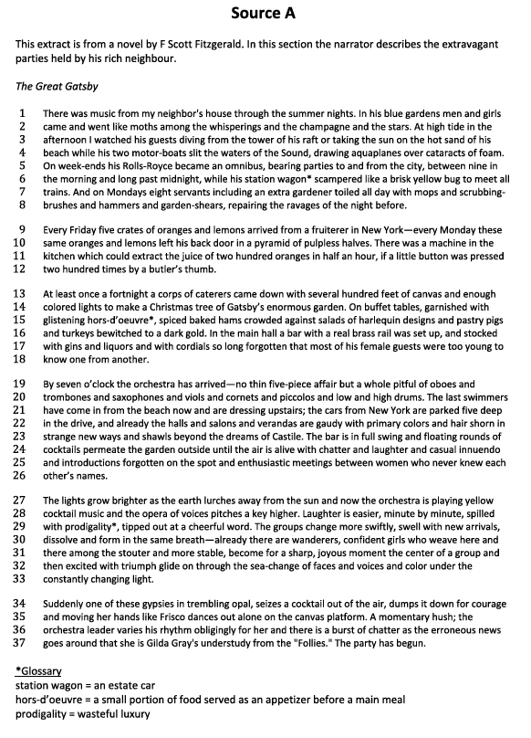
Section A: Reading

Q1. Read again the first part of the Source from lines 1 to 8.
For each of the following statements about Gatsby’s house and parties, choose the most accurate answer:

1. When do Gatsby’s parties take place?
- During the winter
- On quiet weekdays
- On summer weekends
- Every single night
2. What type of fruit is delivered to Gatsby’s house?
- Apples and pears
- Strawberries and bananas
- Oranges and lemons
- Grapes and pineapples
3. What do Gatsby’s parties include?
- Quiet conversations
- Simple dinners
- Music and decorations
- Book readings
4. Who comes to Gatsby’s house for the parties?
- People from nearby towns
- People from New York
- Only close family
- Only staff

[4 marks]

Q2. Look in detail at this extract from lines 1 to 18 of the Source.
How does the writer use language to describe the extravagance of Gatsby’s parties?
You could include the writer’s choice of:
- Words and phrases
- Language features and techniques
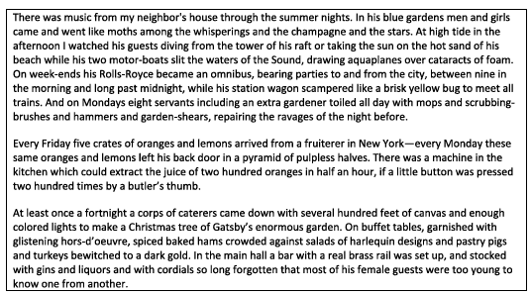
- Sentence forms
[8 marks]

Q3. Now read the whole of Source A.
How has the writer structured the text to create a sense of celebration?
You could write about:
- What the writer focuses your attention on at the beginning
- How and why the writer changes this focus as the Source develops
- Any other structural features that create a celebratory tone
[8 marks]

Q4. Focus this part of your answer on the second part of the Source from line 19 to the end.
The writer brings the party scene vividly to life for the reader.
To what extent do you agree with this statement?
In your response, you could:
- Write about your own impressions of the party scene
- Evaluate how the writer uses methods to create those impressions
- Support your ideas with references to the text
[20 marks]

Section B: Writing
Q5. Choose one:
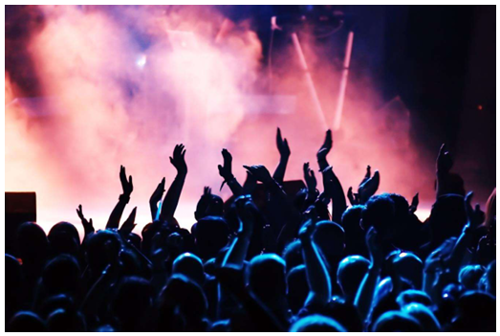
Option A: Description
Write a description of a party, as suggested by this picture.
You can use your imagination—you do not have to describe the picture exactly.

Option B: Narrative Opening
Write the opening of a story in which a glamorous event takes an unexpected turn.
You do not need to write the whole story.

[40 marks: 24 for content and organisation, 16 for technical accuracy]

Writing pages:
__________________________________________________________________________________________________________________________________________________________________________________________________________________________________________________________________________________________________________________________________________________________________________________________________________________________________________________________________________________________________________________________________________________________________________________________________________________________________________________________________________________________________________________________________________________________________________________________________________________________________________________________________________________________________________________________________________________________________________________________________________________________________________________________________________________________________________________________________________________________________________________________________________________________________________________________________________________________________________________________________________________________________________________________________________________________________________________________________________________________________________________________________________________________________________________________________________________________________________________________________________________________________________________________________________________________________________________________________________________________________________________________________________________________________________________________________________________________________________________________________________________________________________________________________________________________________________________________________________________________________________________________________________________________________________________________________________________________________________________________________________________________________________________________________________________________________________________________________________________________________________________________________________________________________________________________________________________________________________________________________________________________________________________________________________________________________________________________________________________________________________________________________________________________________________________________________________________________________________________________________________________________________________________________________________________________________________________________________________________________________________________________________________________________________________________________________________________________________________________________________________________________________________________________________________________________
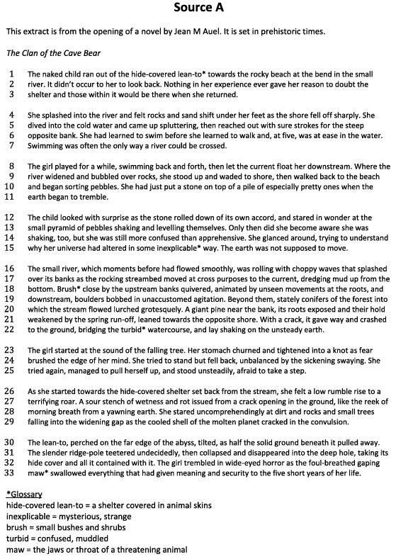
Section A: Reading

Q1. Read again the first part of the Source from lines 1 to 7.
For each of the following statements about the girl, choose the most accurate answer.

1. What does the girl do first in the extract?
- Collects food
- Climbs a tree
- Walks to the river
- Speaks to someone
2. How old is the girl?
- Three
- Five
- Seven
- Ten
3. What does the girl know how to do?
- Build a hut
- Cook food
- Swim
- Hunt
4. What covers the girl’s shelter?
- Leaves
- Animal fur
- Wood
- Grass

[4 marks]

Q2. Look in detail at this extract from lines 23 to 33 of the Source.
How does the writer use language to describe the girl’s reaction to the earthquake?
You could include the writer’s choice of:
- Words and phrases
- Language features and techniques
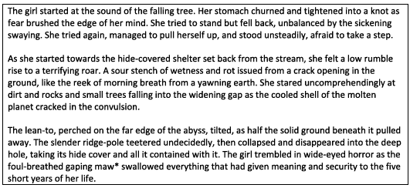
- Sentence forms

[8 marks]
Q3. Now read the whole of Source A.
How has the writer structured the text to create a sense of danger?
You could write about:
- What the writer focuses your attention on at the beginning
- How and why the writer changes this focus as the Source develops
- Any other structural features that create a sense of danger
[8 marks]
Q4. Focus this part of your answer on the first part of the Source from line 1 to line 22.
The writer makes the earthquake seem truly terrifying.
To what extent do you agree with this statement?
In your response, you could:
- Write about your own impressions of the earthquake
- Evaluate how the writer uses methods to create those impressions
- Support your ideas with references to the text
[20 marks]
Section B: Writing
Q5. Choose one:
Option A: Description
Write a description of a sudden catastrophe, as suggested by this picture.
You can use your imagination—you do not have to describe the picture exactly.
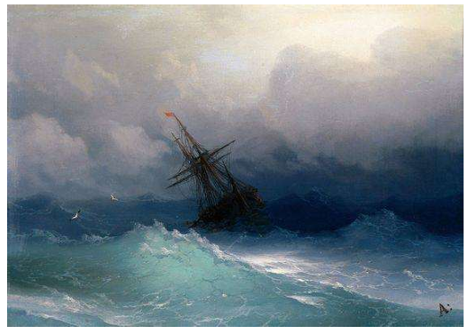

Option B: Narrative Opening
Write the opening of a story set in either the distant past or the distant future.
You do not need to write the whole story.

[40 marks: 24 for content and organisation, 16 for technical accuracy]

Writing pages:
__________________________________________________________________________________________________________________________________________________________________________________________________________________________________________________________________________________________________________________________________________________________________________________________________________________________________________________________________________________________________________________________________________________________________________________________________________________________________________________________________________________________________________________________________________________________________________________________________________________________________________________________________________________________________________________________________________________________________________________________________________________________________________________________________________________________________________________________________________________________________________________________________________________________________________________________________________________________________________________________________________________________________________________________________________________________________________________________________________________________________________________________________________________________________________________________________________________________________________________________________________________________________________________________________________________________________________________________________________________________________________________________________________________________________________________________________________________________________________________________________________________________________________________________________________________________________________________________________________________________________________________________________________________________________________________________________________________________________________________________________________________________________________________________________________________________________________________________________________________________________________________________________________________________________________________________________________________________________________________________________________________________________________________________________________________________________________________________________________________________________________________________________________________________________________________________________________________________________________________________________________________________________________________________________________________________________________________________________________________________________________________________________________________________________________________________________________________________________________________________________________________________________________________________________________________________
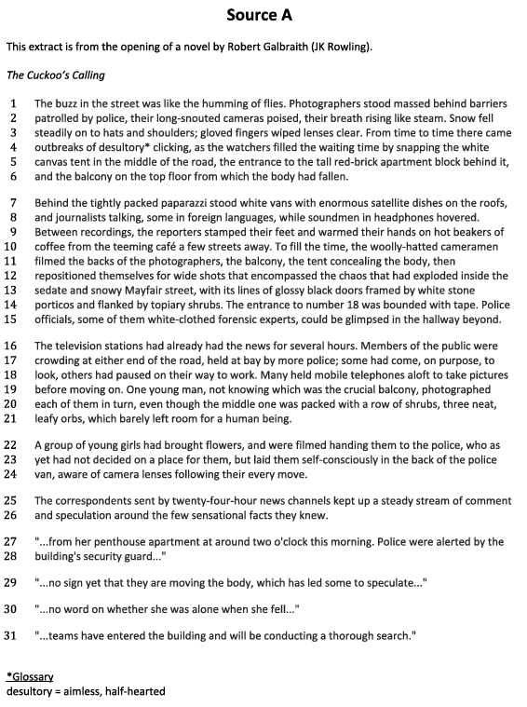
Section A: Reading

Q1. Read again the first part of the Source from lines 1 to 6.
For each of the following statements about the street scene, choose the most accurate answer.

1. What is falling from the sky?
- Rain
- Leaves
- Dust
- Snow
2. What are the photographers doing?
- Standing and taking pictures
- Calling for interviews
- Filming documentaries
- Fixing cables
3. What object is in the middle of the road?
- A stage
- A white tent
- A taxi
- A bus
4. What building is shown behind the tent?
- A school
- A church
- An apartment block
- A hospital

[4 marks]

Q2. Look in detail at this extract from lines 9 to 24 of the Source.
How does the writer use language here to give a sense of different people's reactions to the crime scene?
You could include the writer’s choice of:
- Words and phrases
- Language features and techniques
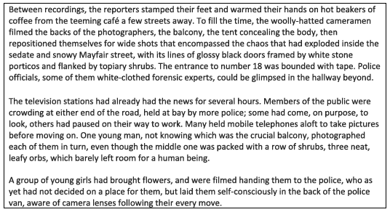
- Sentence forms
[8 marks]

Q3. Now read the whole of Source A.
How has the writer structured the text to create a sense of confusion?
You could write about:
- What the writer focuses your attention on at the beginning
- How and why the writer changes this focus as the Source develops
- Any other structural features that create confusion
[8 marks]

Q4. Focus this part of your answer on the second part of the Source from line 16 to the end.
The writer makes the reader feel just as confused as the people in the scene.
To what extent do you agree?
In your response, you could:
- Write about your own impressions of what is happening in this section
- Evaluate how the writer uses methods to create those impressions
- Support your ideas with references to the text
[20 marks]

Section B: Writing
Q5. Choose one:
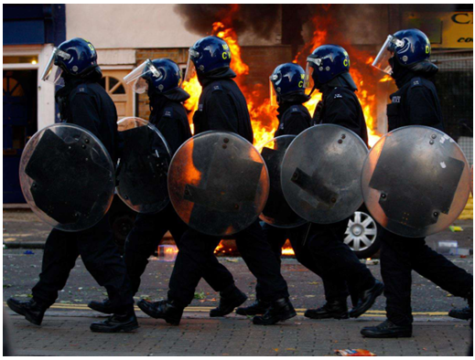
Option A: Description
Write a description of a tragic scene, as suggested by this picture.
You can use your imagination—you do not have to describe the picture exactly.

Option B: Narrative Opening
Write the opening of a crime or mystery story.
You do not need to write the whole story.

[40 marks: 24 for content and organisation, 16 for technical accuracy]

Writing pages:
__________________________________________________________________________________________________________________________________________________________________________________________________________________________________________________________________________________________________________________________________________________________________________________________________________________________________________________________________________________________________________________________________________________________________________________________________________________________________________________________________________________________________________________________________________________________________________________________________________________________________________________________________________________________________________________________________________________________________________________________________________________________________________________________________________________________________________________________________________________________________________________________________________________________________________________________________________________________________________________________________________________________________________________________________________________________________________________________________________________________________________________________________________________________________________________________________________________________________________________________________________________________________________________________________________________________________________________________________________________________________________________________________________________________________________________________________________________________________________________________________________________________________________________________________________________________________________________________________________________________________________________________________________________________________________________________________________________________________________________________________________________________________________________________________________________________________________________________________________________________________________________________________________________________________________________________________________________________________________________________________________________________________________________________________________________________________________________________________________________________________________________________________________________________________________________________________________________________________________________________________________________________________________________________________________________________________________________________________________________________________________________________________________________________________________________________________________________________________________________________________________________________________________________________________________________________

English Language PAPER 2
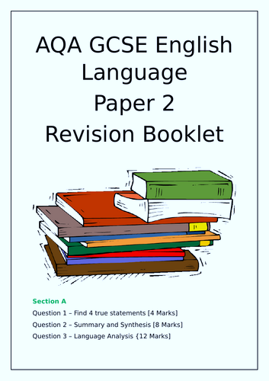
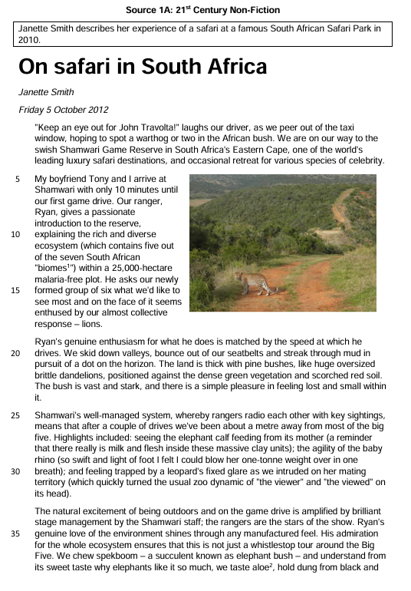
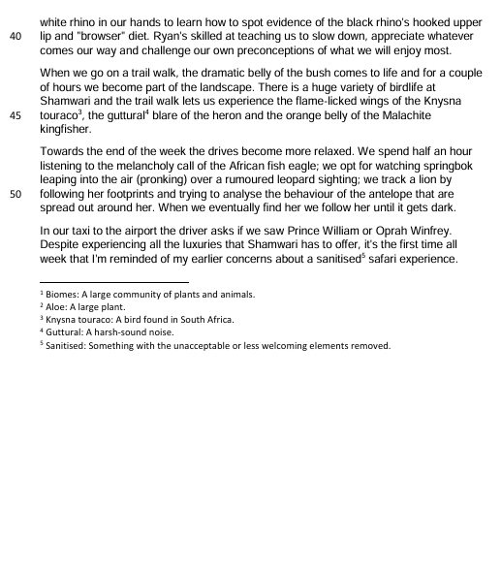

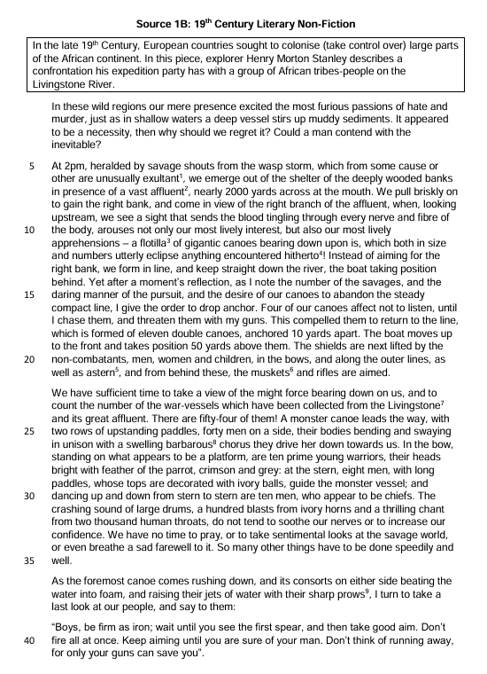

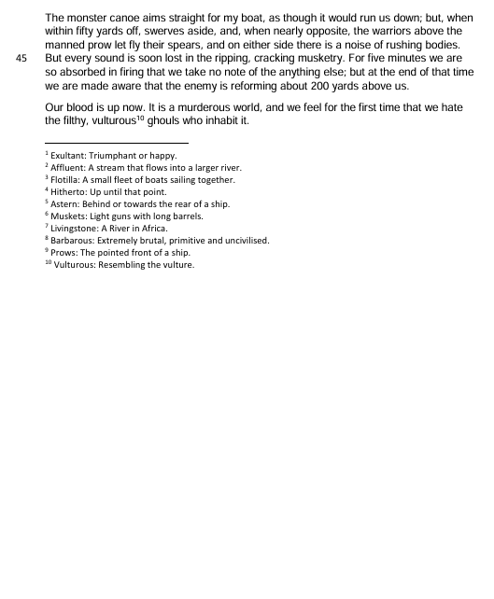

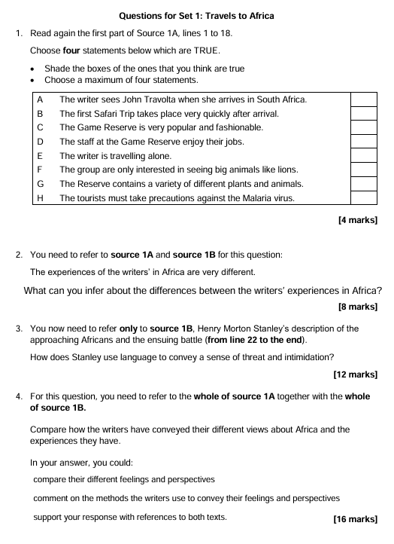


Writing space:
__________________________________________________________________________________________________________________________________________________________________________________________________________________________________________________________________________________________________________________________________________________________________________________________________________________________________________________________________________________________________________________________________________________________________________________________________________________________________________________________________________________________________________________________________________________________________________________________________________________________________________________________________________________________________________________________________________________________________________________________________________________________________________________________________________________________________________________________________________________________________________________________________________________________________________________________________________________________________________________________________________________________________________________________________________________________________________________________________________________________________________________________________________________________________________________________________________________________________________________________________________________________________________________________________________________________________________________________________________________________________________________________________________________________________________________________________________________________________________________________________________________________________________________________________________________________________________________________________________________________________________________________________________________________________________________________________________________________________________________________________________________________________________________________________________________________________________________________________________________________________________________________________________________________________________________________________________________________________________________________________________________________________________________________________________________________________________________________________________________________________________________________________________________________________________________________________________________________________________________________________________________________________________________________________________________________________________________________________________________________________________________________________________________________________________________________________________________________________________________________________________________________________________________________________________________________________________________________________________________________________________________________________________________________________________________________________________________________________________________________________________________________________________________________________________________________________________________________________________________________________________________________________________________________________________________________________________________________________________________________________________________________________________________________________________________________________________________________________________________________________________________________________________________________________________________________________________________________________
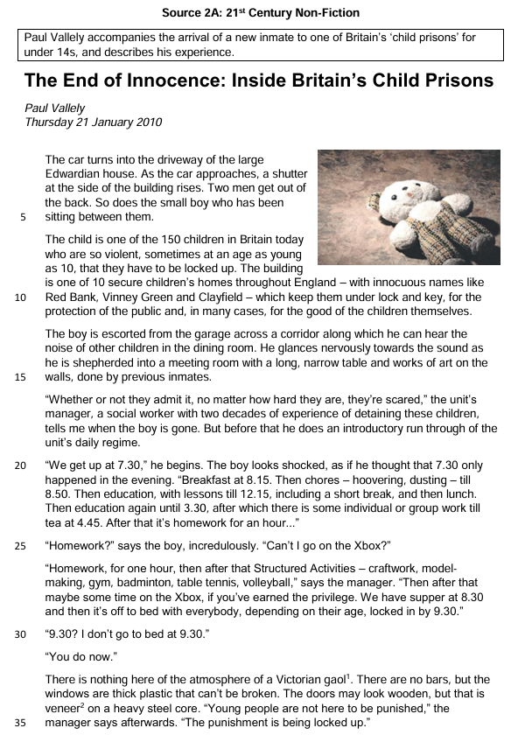

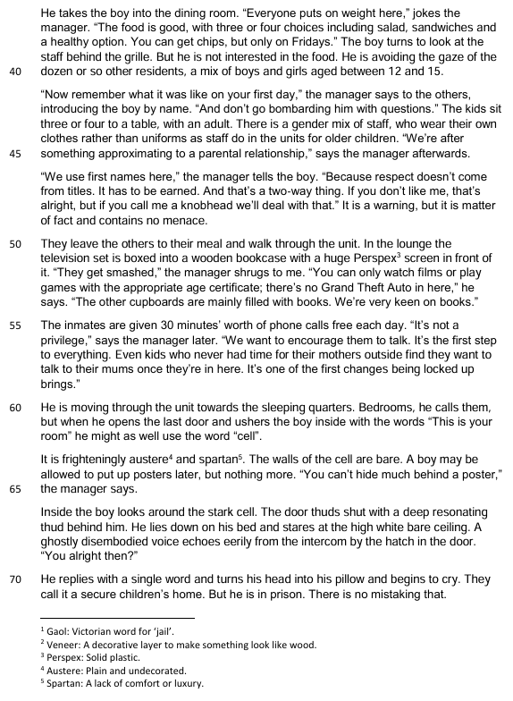

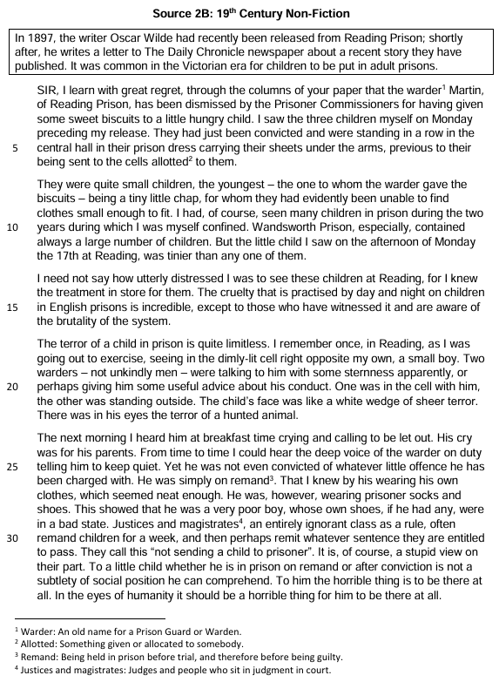

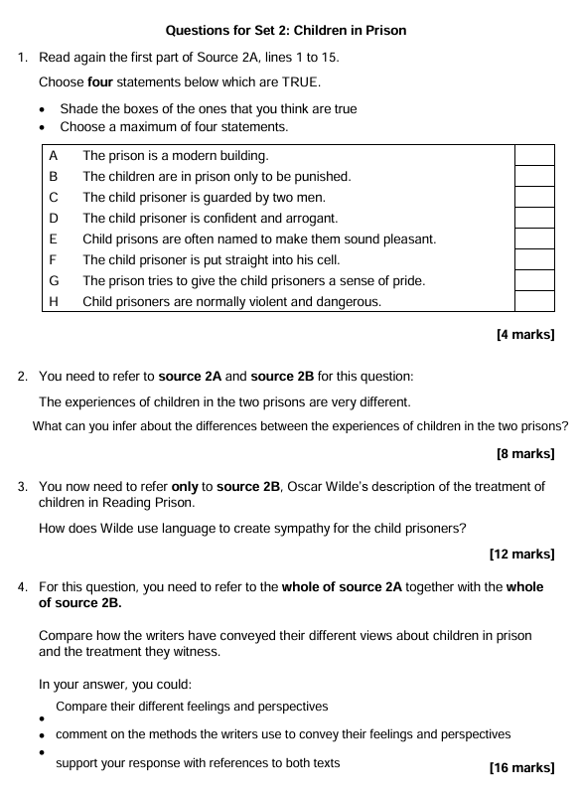
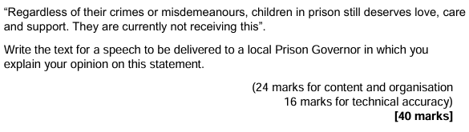

Writing space:
__________________________________________________________________________________________________________________________________________________________________________________________________________________________________________________________________________________________________________________________________________________________________________________________________________________________________________________________________________________________________________________________________________________________________________________________________________________________________________________________________________________________________________________________________________________________________________________________________________________________________________________________________________________________________________________________________________________________________________________________________________________________________________________________________________________________________________________________________________________________________________________________________________________________________________________________________________________________________________________________________________________________________________________________________________________________________________________________________________________________________________________________________________________________________________________________________________________________________________________________________________________________________________________________________________________________________________________________________________________________________________________________________________________________________________________________________________________________________________________________________________________________________________________________________________________________________________________________________________________________________________________________________________________________________________________________________________________________________________________________________________________________________________________________________________________________________________________________________________________________________________________________________________________________________________________________________________________________________________________________________________________________________________________________________________________________________________________________________________________________________________________________________________________________________________________________________________________________________________________________________________________________________________________________________________________________________________________________________________________________________________________________________________________________________________________________________________________________________________________________________________________________________________________________________________________________________________________________________________________________________________________________________________________________________________________________________________________________________________________________________________________________________________________________________________________________________________________________________________________________________________________________________________________________________________________________________________________________________________________________________________________________________________________________________________________________________________________________________________________________________________________________________________________________________________________________________________________________________

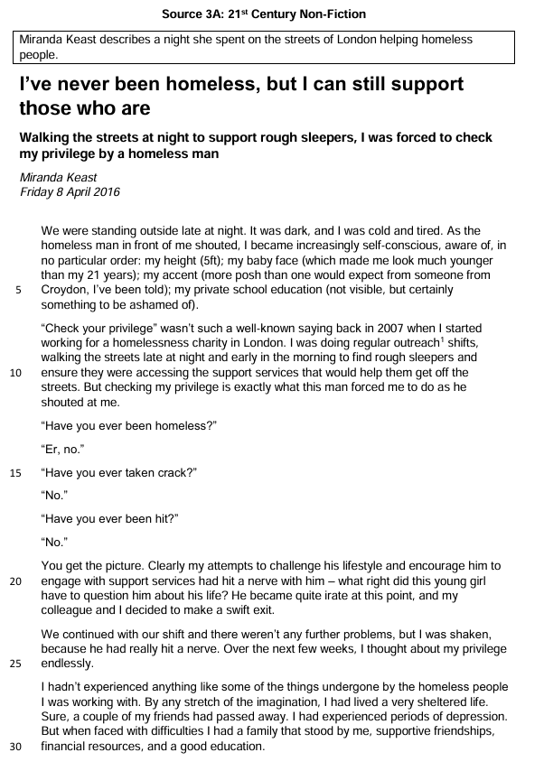

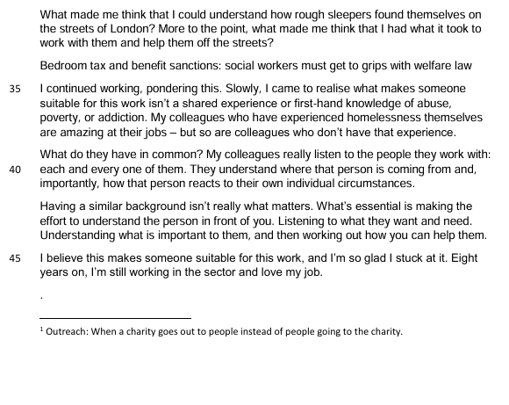

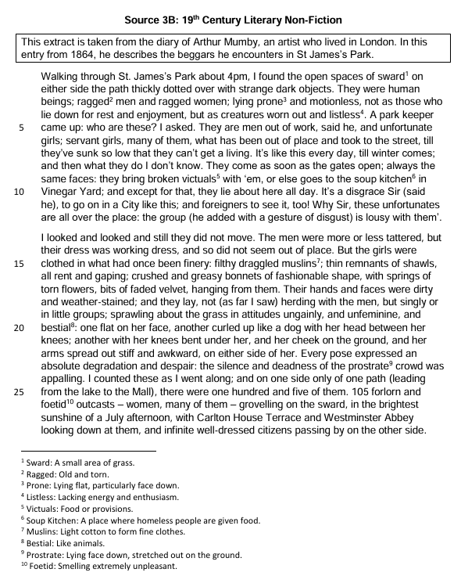

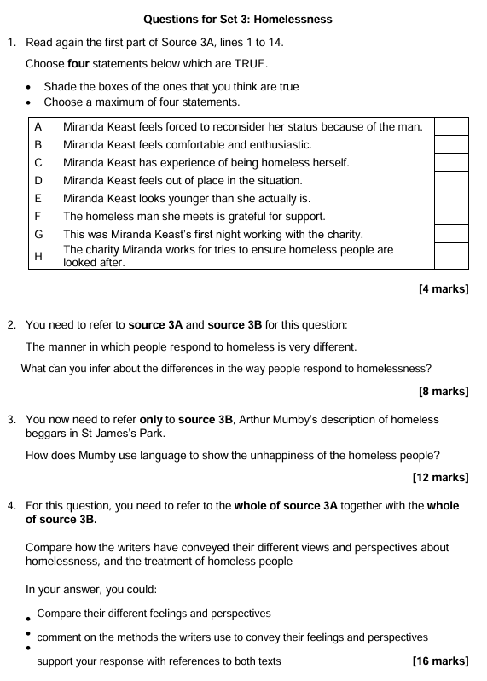

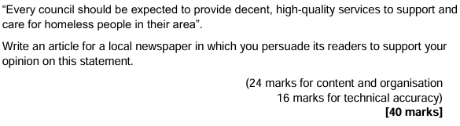
Writing space:
__________________________________________________________________________________________________________________________________________________________________________________________________________________________________________________________________________________________________________________________________________________________________________________________________________________________________________________________________________________________________________________________________________________________________________________________________________________________________________________________________________________________________________________________________________________________________________________________________________________________________________________________________________________________________________________________________________________________________________________________________________________________________________________________________________________________________________________________________________________________________________________________________________________________________________________________________________________________________________________________________________________________________________________________________________________________________________________________________________________________________________________________________________________________________________________________________________________________________________________________________________________________________________________________________________________________________________________________________________________________________________________________________________________________________________________________________________________________________________________________________________________________________________________________________________________________________________________________________________________________________________________________________________________________________________________________________________________________________________________________________________________________________________________________________________________________________________________________________________________________________________________________________________________________________________________________________________________________________________________________________________________________________________________________________________________________________________________________________________________________________________________________________________________________________________________________________________________________________________________________________________________________________________________________________________________________________________________________________________________________________________________________________________________________________________________________________________________________________________________________________________________________________________________________________________________________________________________________________________________________________________________________________________________________________________________________________________________________________________________________________________________________________________________________________________________________________________________________________________________________________________________________________________________________________________________________________________________________________________________________________________________________________________________________________________________________________________________________________________________________________________________________________________________________________________________________________________________________________

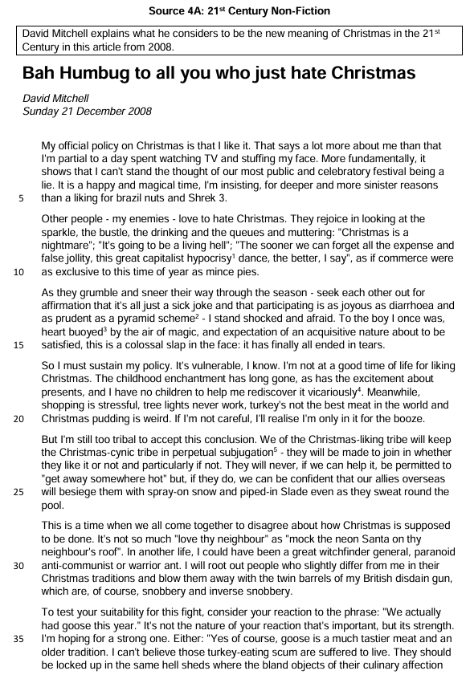
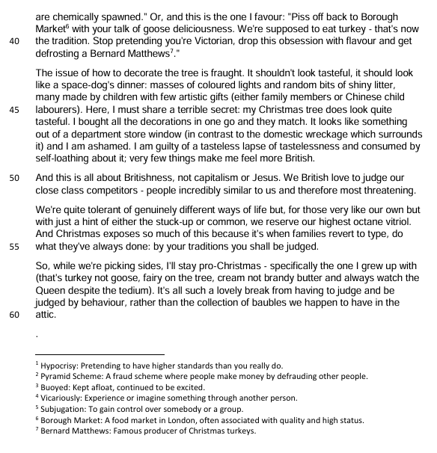

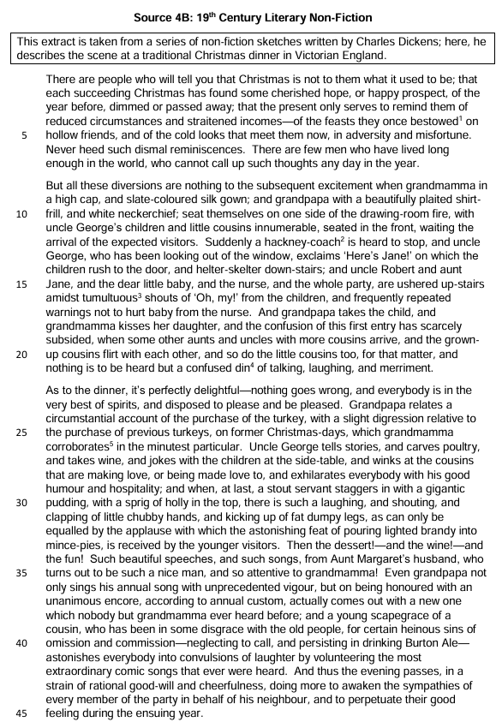

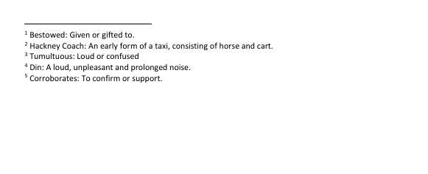

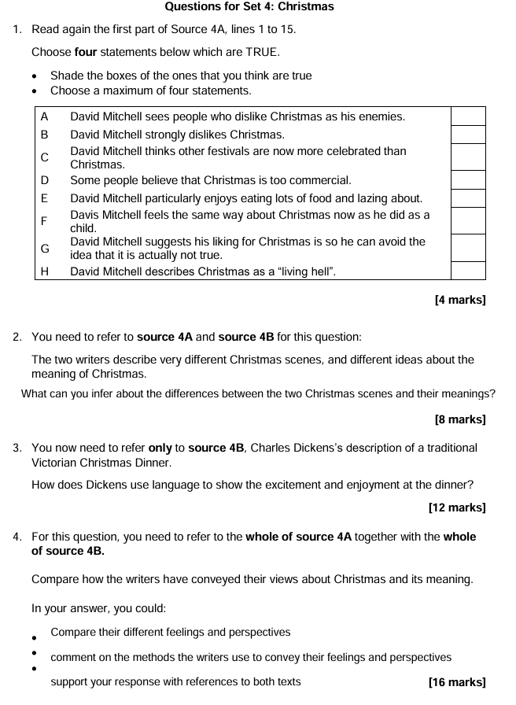

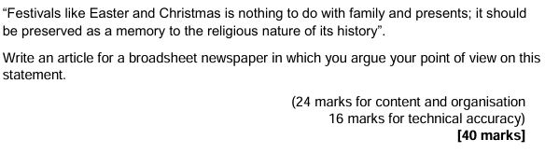
Writing space:
__________________________________________________________________________________________________________________________________________________________________________________________________________________________________________________________________________________________________________________________________________________________________________________________________________________________________________________________________________________________________________________________________________________________________________________________________________________________________________________________________________________________________________________________________________________________________________________________________________________________________________________________________________________________________________________________________________________________________________________________________________________________________________________________________________________________________________________________________________________________________________________________________________________________________________________________________________________________________________________________________________________________________________________________________________________________________________________________________________________________________________________________________________________________________________________________________________________________________________________________________________________________________________________________________________________________________________________________________________________________________________________________________________________________________________________________________________________________________________________________________________________________________________________________________________________________________________________________________________________________________________________________________________________________________________________________________________________________________________________________________________________________________________________________________________________________________________________________________________________________________________________________________________________________________________________________________________________________________________________________________________________________________________________________________________________________________________________________________________________________________________________________________________________________________________________________________________________________________________________________________________________________________________________________________________________________________________________________________________________________________________________________________________________________________________________________________________________________________________________________________________________________________________________________________________________________________________________________________________________________________________________________________________________________________________________________________________________________________________________________________________________________________________________________________________________________________________________________________________________________________________________________________________________________________________________________________________________________________________________________________________________________________________________________________________________________________________________________________________________________________________________________________________________________________________________________________________________________________

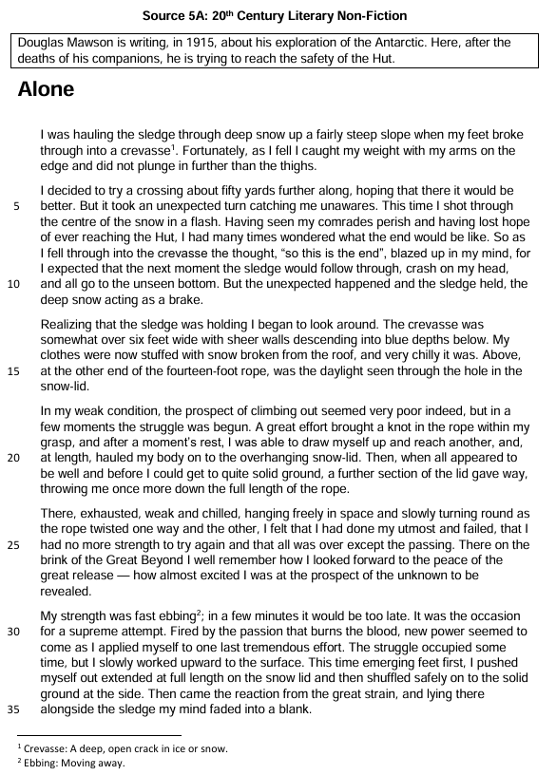
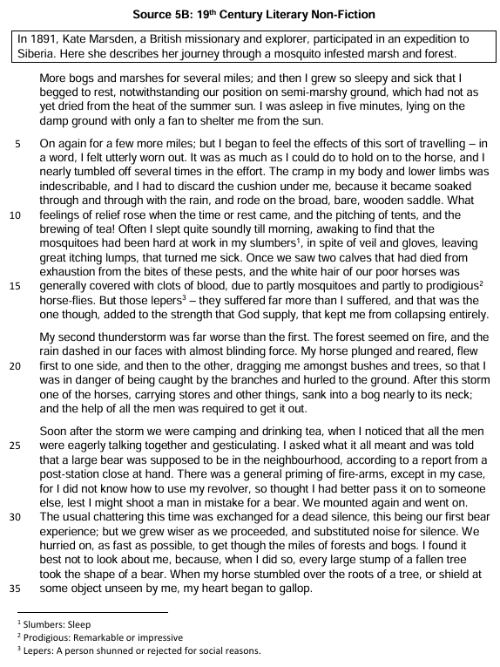

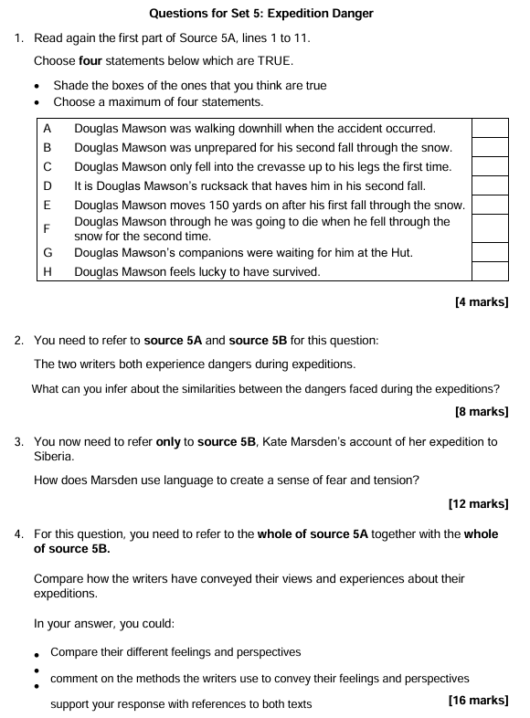

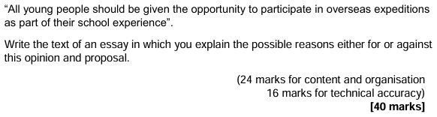
Writing space:
__________________________________________________________________________________________________________________________________________________________________________________________________________________________________________________________________________________________________________________________________________________________________________________________________________________________________________________________________________________________________________________________________________________________________________________________________________________________________________________________________________________________________________________________________________________________________________________________________________________________________________________________________________________________________________________________________________________________________________________________________________________________________________________________________________________________________________________________________________________________________________________________________________________________________________________________________________________________________________________________________________________________________________________________________________________________________________________________________________________________________________________________________________________________________________________________________________________________________________________________________________________________________________________________________________________________________________________________________________________________________________________________________________________________________________________________________________________________________________________________________________________________________________________________________________________________________________________________________________________________________________________________________________________________________________________________________________________________________________________________________________________________________________________________________________________________________________________________________________________________________________________________________________________________________________________________________________________________________________________________________________________________________________________________________________________________________________________________________________________________________________________________________________________________________________________________________________________________________________________________________________________________________________________________________________________________________________________________________________________________________________________________________________________________________________________________________________________________________________________________________________________________________________________________________________________________________________________________________________________________________________________________________________________________________________________________________________________________________________________________________________________________________________________________________________________________________________________________________________________________________________________________________________________________________________________________________________________________________________________________________________________________________________________________________________________________________________________________________________________________________________________________________________________________________________________________________________________________________
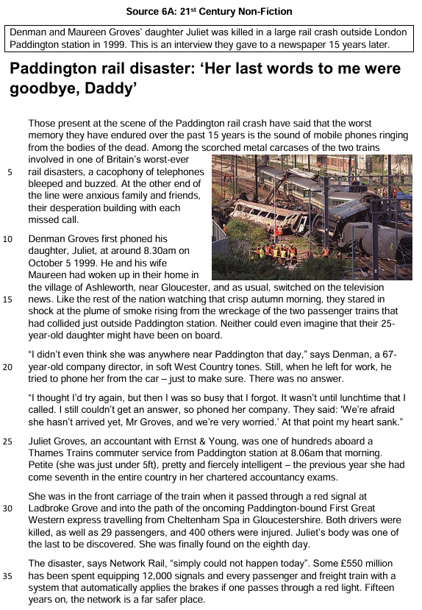
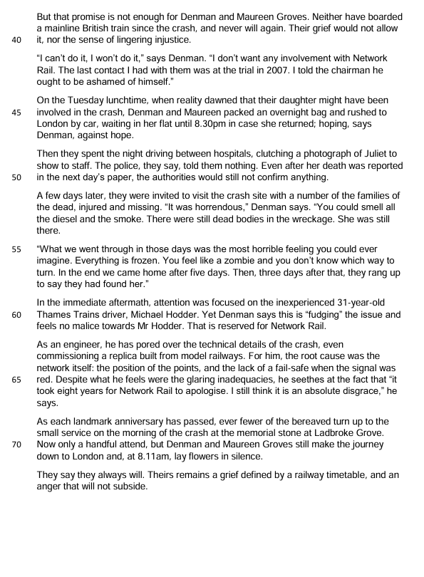

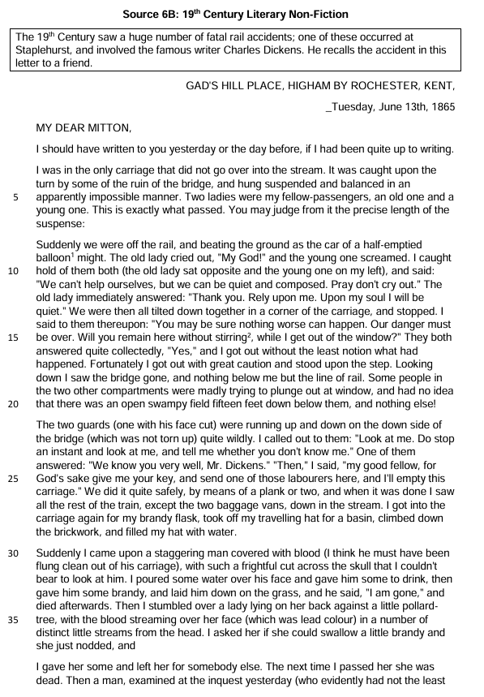

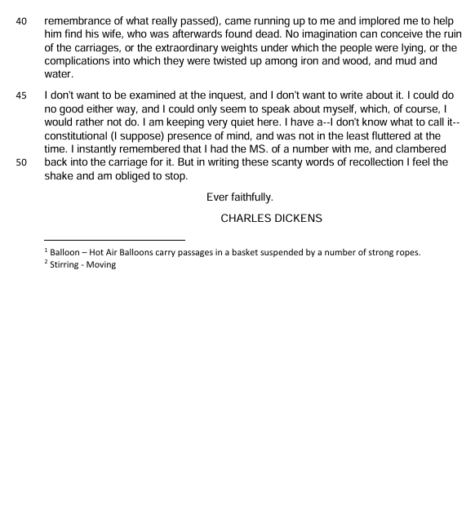

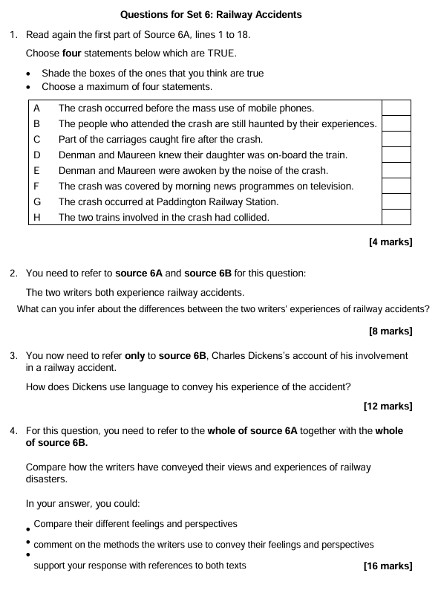

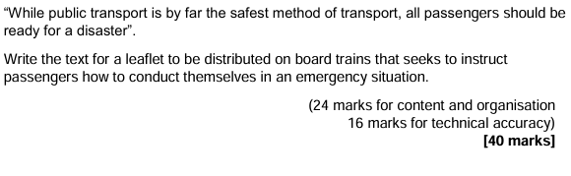
Writing space:
__________________________________________________________________________________________________________________________________________________________________________________________________________________________________________________________________________________________________________________________________________________________________________________________________________________________________________________________________________________________________________________________________________________________________________________________________________________________________________________________________________________________________________________________________________________________________________________________________________________________________________________________________________________________________________________________________________________________________________________________________________________________________________________________________________________________________________________________________________________________________________________________________________________________________________________________________________________________________________________________________________________________________________________________________________________________________________________________________________________________________________________________________________________________________________________________________________________________________________________________________________________________________________________________________________________________________________________________________________________________________________________________________________________________________________________________________________________________________________________________________________________________________________________________________________________________________________________________________________________________________________________________________________________________________________________________________________________________________________________________________________________________________________________________________________________________________________________________________________________________________________________________________________________________________________________________________________________________________________________________________________________________________________________________________________________________________________________________________________________________________________________________________________________________________________________________________________________________________________________________________________________________________________________________________________________________________________________________________________________________________________________________________________________________________________________________________________________________________________________________________________________________________________________________________________________________________________________________________________________________________________________________________________________________________________________________________________________________________________________________________________________________________________________________________________________________________________________________________________________________________________________________________________________________________________________________________________________________________________________________________________________________________________________________________________________________________________________________________________________________________________________________________________________________________________________________________________________________________

